**Literature Review of Reliability Model and methods**

**Reliability Model:**

Reliability:  is the absence of failures in products and systems.

Reliability Engineering: is defined as the management function that prevents the creation of failures by people (such as systems engineers, design engineers, production personnel, users and maintenance personnel).

The ideal state of **‘absence of failures**’ is achieved in practice by preventing failures from occurring. This is only possible if there is a thorough understanding of all of the potential failure modes and then taking appropriate steps to prevent them from occurring. Understanding potential failure modes are achieved by analyzing and testing during both the design and the production phases of a project [7].

In the system engineering, the most common definition of reliability says that reliability of a component or system is the probability that the component or system will perform its intended function under specified operational and environmental conditions during a specified interval.

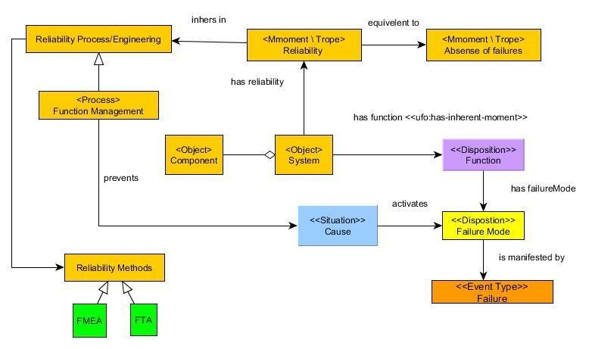

**Reliability Model  wrt Value Proposition Model [6]:**

**Reliability Methods:**

**Failure Analysis**: Failure analysis, performed with the objective of understanding how the product or system will react to potential failure modes, is extremely useful to influence a design. Typical analyses include FMEA (Failure Mode and Effects Analysis), FTA (Fault Tree Analysis) and reliability block diagram analysis.

* **Failure modes and effects analysis (FMEA)** is a step-by-step approach for identifying all possible failures in a design, a manufacturing or assembly process, or a product or service. Where ‘failure modes’ means the ways, or modes, in which something might fail. FMEA is a bottom-up analysis where potential failure modes of a product or system are identified, and the effects of these failure modes on a higher level are determined. For each potential failure mode, the probability of occurrence and the ability to detect it are also determined.

The focus of a design FMEA, is on how to prevent failure from occurring in the first place! It requires substantial technical input from design engineers.

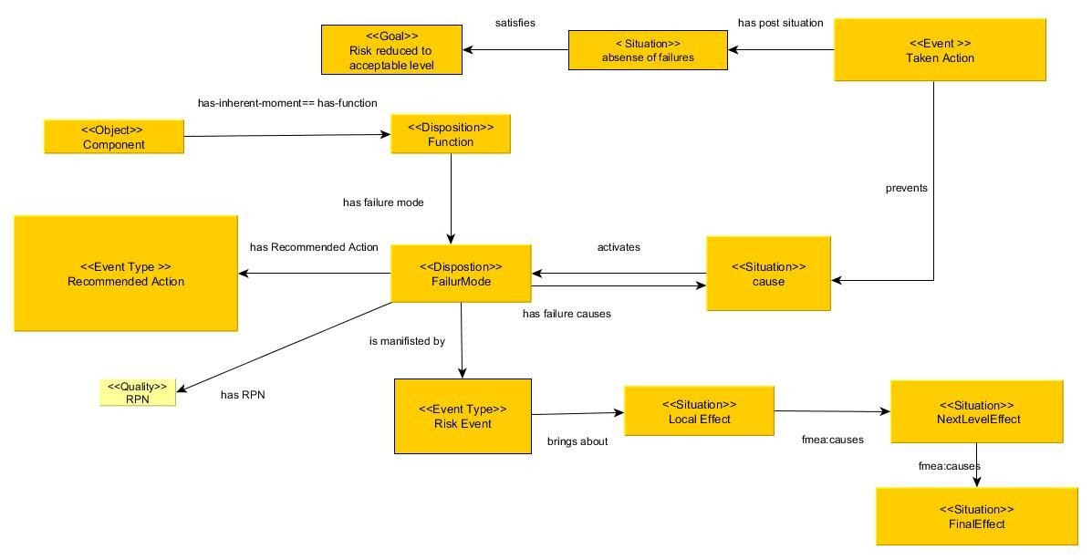

* **FTA** uses top-down logic to determine what failures (and in what combinations) can cause an undesirable event to occur, applying deductive reasoning to analyze an undesired state of a system using Boolean logic to combine a series of lower-level events.

FTA analysis involves five steps:

 1. Define the undesired event to study

 2. Obtain an understanding of the system

3. Construct the fault tree

4. Evaluate the fault tree

5. Control the hazards identified

**FTA Model**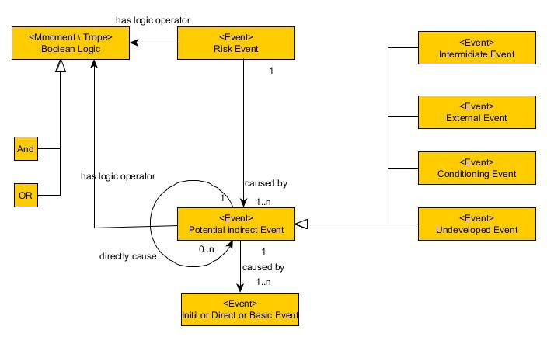

**FTA Example:**

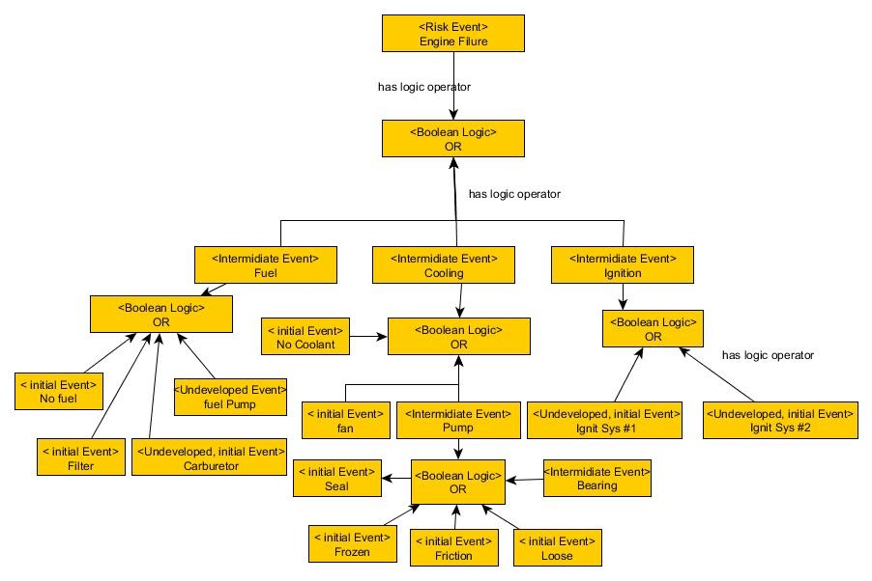

* **Reliability block diagram**: A reliability block diagram (RBD) is a diagrammatic method for showing how component reliability contributes to the success or failure of a complex system. RBD is also known as a dependence diagram (DD). It is drawn as a series of blocks connected in parallel or series configuration. Each block represents a component of the system with a failure rate. Reliability block diagrams often correspond to the physical arrangement of components in the system being modelled. However, in certain cases, this may not apply.

The probability of system failure can be calculated as can the potential for a complex system to keep operating with some of its systems in failure mode.

**Related Researches:**

**Ontology-Based Software Reliability Modelling:** ‘Software reliability’  refers to the probability of failure-free operation of a computer program in a specified environment over a specified period of time.

Defining reliability means quantitative reliability definition of a **software system**, which in turn makes it possible for reliability experts to balance customer needs for reliability, delivery date, and cost [1].

**Reliability considering Environmental Effects**: studied the impact of environmental effects on product reliability. It proposed a method to apply the ontology approach in product design [2].

The reliability of the **aircraft systems** has an important contribution to accidents and incidents in the overall aviation system. Aircraft system or component failure (SCF-NP) is the third accident category by number of fatal accidents (6), after “Loss of control in-flight (LOC-I) (9) and “Controlled Flight Into Terrain” (CFIT) (7) and the second by total number of accidents (62), after “Abnormal runway contact” (ARC) (66) (EASA member states operated aeroplanes for the period 2002 – 2011). In addition to the direct loss of primary function, less severe system/component failures/malfunctions could contribute to accident propagation, e.g. loss of control, abnormal runway contact, etc. System failures could be related to design errors, manufacturing and maintenance issues. Included are errors or failures in software and database systems [3].

The reliability of the **logistics** in Supply Chain (SC) is realized as an important factor in order to provide a high quality of service to customers [4].

**In Aviation Safety Domain**:  there is research that aim to analyze and describe the current situation of reliability methodologies in the aviation industry, identify limitations and deficiencies of the reliability analysis. Also, it created an ontological model for FMEA methodology.

**An overview of Fault Tree Analysis and its application in model based dependability analysis [8]:** it provided an overview of fault tree analysis. Although FTA is a highly successful and widely-used method for dependability analysis of wide variety of systems, it does have a number of limitations, such as an inability to model sequence- or time-dependent dynamic behaviour and to perform quantitative analysis with uncertain failure data. In addition to that, even where software tool support exists for FTA, it requires a lot of manual efforts to create and analyse fault trees. Different extensions of standard fault trees have been proposed to overcome some of the limitations. Many of these extensions are also discussed in this research.

* **Interesting points**: section 4 reviews different model-based dependability analysis approaches which applied FTA as a means for their analysis technique and automatically or semi-automatically generates fault trees from extended system models. Examples:
  + HiP-HOPS: it can automatically generate fault trees, FMEA tables, perform quantitative analysis on fault trees, and has the ability to perform multi-objective optimisation of the system models

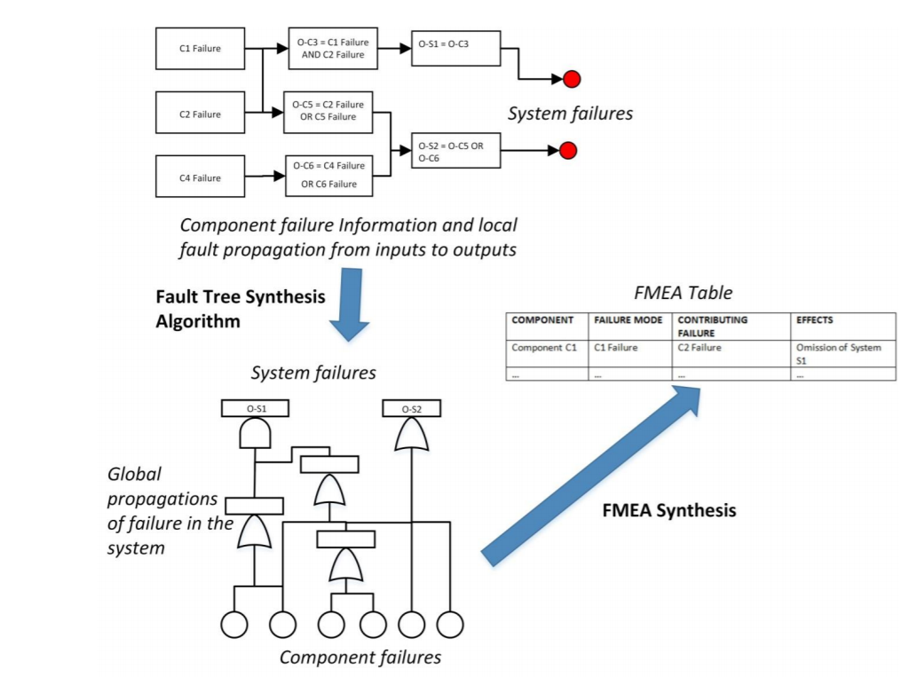

* AltaRica is a high level description language (based on finite state machines designed to model both functional and failure behaviour of complex systems. It can represent systems as hierarchies of components and subcomponents and model both state and event like State-Event fault trees. Once a system has been modelled in AltaRica, it can be analysed by external tools and methods, e.g., the generation of fault trees, Petri nets, model-checking etc.(

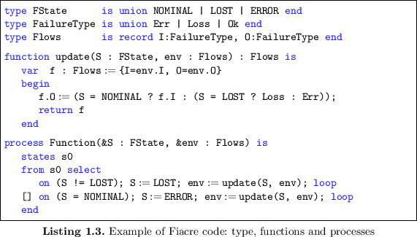

**References:**

1. Zhou, Jiehan & Ovaska, Eila & Evesti, Antti. (2007). Ontology-based software reliability modelling.
2. Sun, Bo & Li, Yu & Ye, Tianyuan & Ren, Yi. (2015). A Novel Ontology Approach to Support Design for Reliability considering Environmental Effects. TheScientificWorldJournal. 2015. 734984. 10.1155/2015/734984.
3. Georgiev, Krasin. (2013). Implementation of Reliability Analysis of an Aircraft System.
4. Kim, Eun-ji et al. “A Reliability Model of Truck Transportation Using FMEA and FTA.” (2015).
5. ,Bolčeková.S, Lalis.A.: Reliability Analysis of Mechanical and Lubrication System of Aircraft Engine.
6. Prince Sales, Tiago & Guarino, Nicola & Guizzardi, Giancarlo & Mylopoulos, John. (2017). An Ontological Analysis of Value Propositions. 10.1109/EDOC.2017.32.
7. <https://mosaicprojects.com.au/WhitePapers/WP1003_FMEA.pdf?fbclid=IwAR3YGq7u7bm24u0LaDut-j5jwLcOjHG4hZO81RnMAwNhzO296YnWZS4WaWk>
8. [Kabir, Sohag. 'An overview of fault tree analysis and its application in model based dependability analysis.' Expert Systems with Applications 77 (2017): 114-135.](https://scholar.google.com/scholar?hl=sk&as_sdt=0%2C5&q=An+overview+of+Fault+Tree+Analysis+and+its+application+in+model+based+dependability+analysis&btnG=)